Case 6-Afr-DR Congo-*N’kisi nkondi mazita* -Statue-Male-Wood and Hemp Rope-19th c

*Note: The Democratic Republic of the Congo (DR Congo) has been known as, in chronological order, the Congo Free State, Belgian Congo, the Republic of Congo-Léopoldville, the Democratic Republic of the Congo and the Republic of Zaire, before returning to its current name the DR Congo.*

*Note: The Kongo people (singular: Mukongo, pl. Bakongo) speak Kikongo, a Bantu language, who have lived along the Atlantic coast of Central Africa, in a region that, by the 15th century, was a centralized and well-organized Kongo Kingdom but is now a part of three countries: DR Congo, the Republic of the Congo and Angola.*

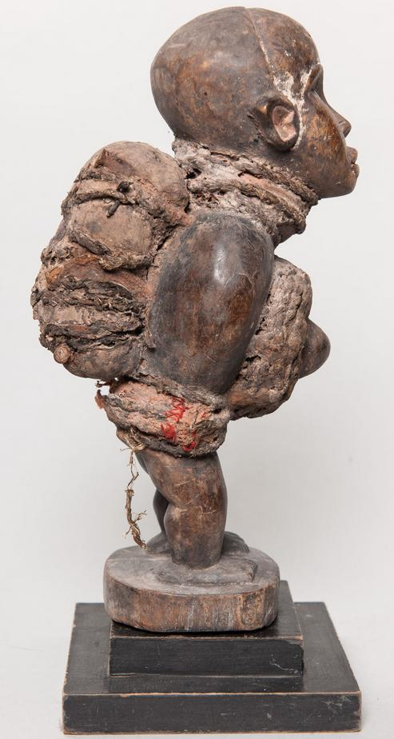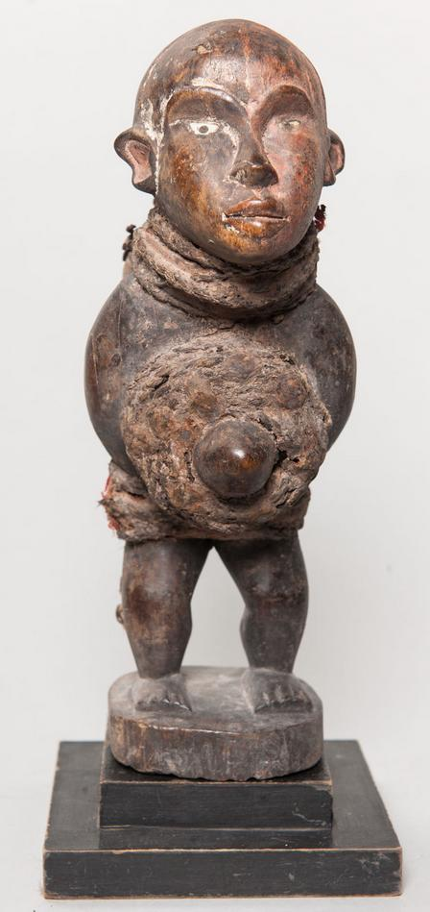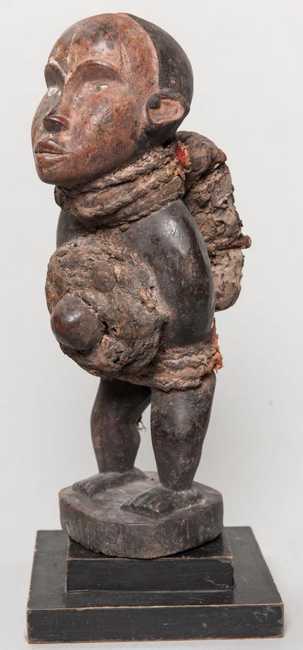

Figs. 1-3. Congo DR- *N’kisi nkondi mazita* -Statue-Male-Wood and Hemp Rope-19th c, Atlantika Collection.

**Case no.: 6**

**Accession Number:**

**Formal Label:**

**Display Description:**

This particular *n’kisi nkondi mazita* uses knots called *mazita* (“tying up”) as a compilation of problems that are to be solved. The knot tying process involves slicing up palm leaves and tying them in knotted bundles on behalf of the “client” seeking solutions by the priest (*nganga’a n’kisi)*. Each client request of assistance and the acknowledgement of the request by the *nganga’a n’kisi* is recorded by each knot.

**LC Classification:** NB1099.C6

**Date or Time Horizon:** 19th c

**Geographical Area:** DR Congo

**Map:**

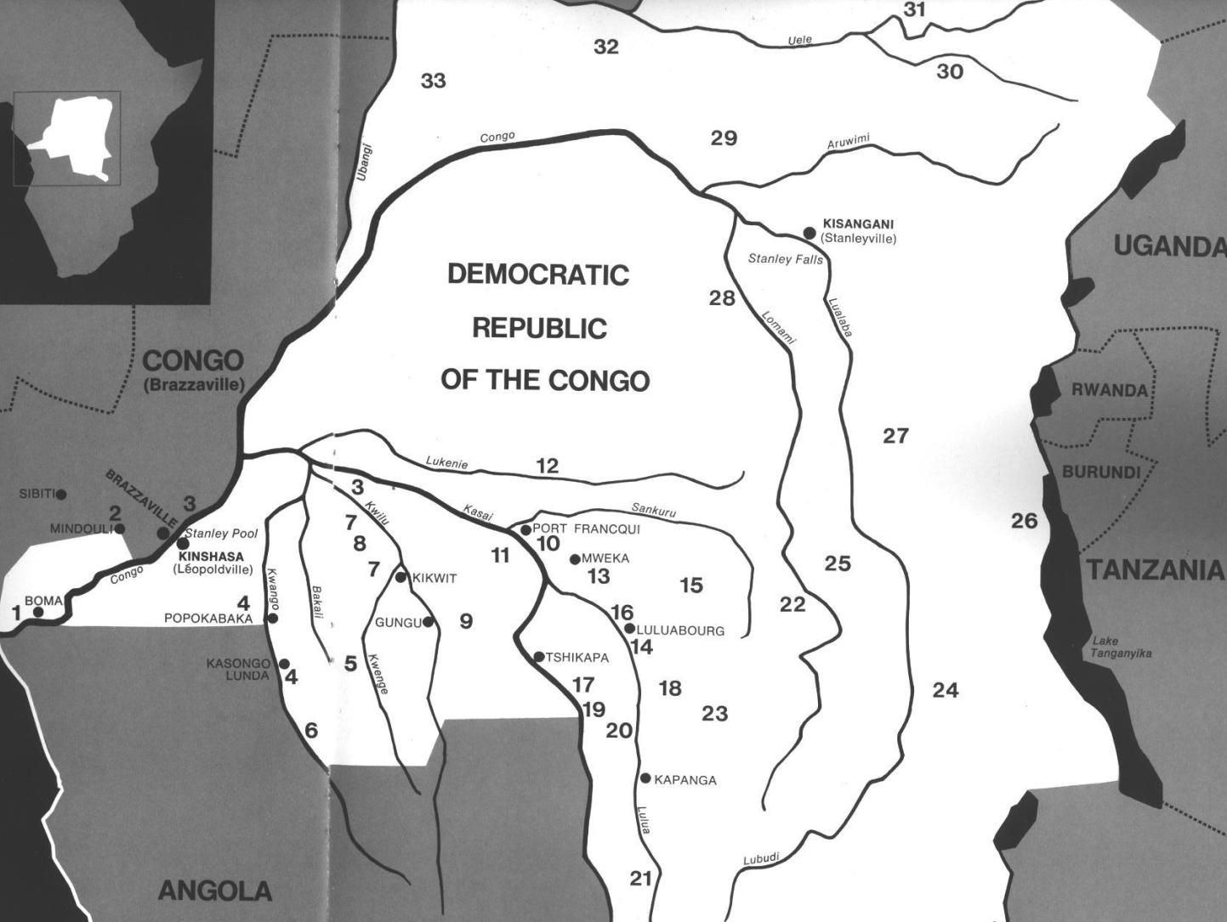

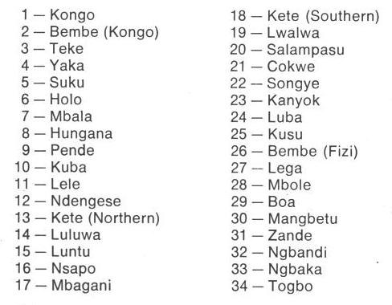

Fig. 4. Map of Kongo Cultures, West Central Africa. After Walker Art Center 1967.

**GPS coordinates:**

**Cultural Affiliation:** Kongo peoples

**Media:** wood, fiber, beads, and leather

**Dimensions:** H 12.20 in

**Weight: 1.19 pounds**

**Condition: original**

**Provenance:**

**Discussion:**

In practice, knots have ten different forms according to Barbaro Martinez-Ruiz (2013:168-169).

1) Nkeka kanga-single knot signifies closure of a single issue

2) Mazita a tatu-several knots tied in a row signifying difficult issues

3) Zeta seka kia kubula-broom like knot signifying spiritual cleansing

4) Zita lubamba-circular knots binding grass in a circle signifying completion

5) Seve kia lukamba-two knots in figure eight signifying restoration of goodwill with deceased

6) Zita dia vakika-reef knot tying two ropes together signifying tying multiple issues together

7) Zita dis kanga-butterfly knot ties along length of rope signifying silencing antagonisms

8) Simi dia ndala-cover used to seal wine bottle signifying issues sealed temporarily

9) Zita a nkita-end of rope knotted to secure its strands signifying cure of illnesses

10) Nsoko wa diya-helix knot signifying three components: head (psychological issues). Upper torso (physical issues), lower body (ancestor issues).

**References:**

Adams, Monni. 1988. 8th century Kuba king figures, *African Art* 21(3): 32-38, 88.

Belepe, Bope. 1974. *Etude socio-morphologique des masques Bwoom des Kuba: Memoire de licence en histoire.* Lubumbashi: Université Nationale du Zaire.

Belepe, Bope. 1981. Les oeuvres plastiques Africaines comme documents d'histoire: Le cas des statues Royales Ndop des Kuba du Zaire, *Africa­Tervuren* 25(1): 9-17.

Binkley, D. 1987. Avatar of power: Southern Kuba masquerade figures in funerary context, *Africa* 57 (1).

Binkley, D. 1990. Masks, space and gender in southern Kuba initiation ritual, *Iowa Studies in Art.* Vol. 3, *Art and Initiation in Zaire.* Iowa City: The University of Iowa.

Brett-Smith, Sarah. 1983. “The Doyle Collection of African Art,” *Record of the Art Museum, Princeton University*, 42(2): 2+8-34.

Kuba du Zaire, Africa­ Tervuren 27(1): 9-17.

Binkley, D. 1987. Avatar of power: Southern Kuba masquerade figures in funerary context, *Africa* 57 (1).

Binkley, D. 1990. Masks, space and gender in southern Kuba initiation ritual, *Iowa Studies in Art.* Vol. 3, *Art and Initiation in Zaire.* Iowa City: The University of Iowa.

Claerhout, A. 1976. Two Kuba wrought-iron statuettes, *African Art* IX (4): 60-64.

Cornet, J. 1972. *Art de l'Afrique Noire au pays du fleuve Zaire*. Brussels: Arcade.

Cornet, J. 1975. *Art from Zaire: 100 Masterworks from the National Collection.* New York: African-American Institute.

Cornet, J. 1982. *Art royal Kuba.* Milan: Sipiel.

Ehret, Christopher. 2002. *The civilizations of Africa: a history to 1800*. Charlottesville: Virginia: University of Virginia Press.

Forbath, Peter. 1977. *The River Congo*. Boston: Houghton Mifflin.

Laman, Karl. 1953. *The Kongo*. 4. vols. Stockholm: Victor Pettersons.

MacGaffey, Wyatt. 1986. *Religion and society in central Africa: the Bakongo of Lower Zaire*. Chicago: University of Chicago Press.

MacGaffey, Wyatt. 1988. “Complexity, astonishment and power: the visual vocabulary of Kongo minkisi,” *Journal of African Studies*, (14:2), 188-203.

Martinez-Ruiz, Barbaro. 2013. *Kongo Graphic Writing and other Narratives of the Sign*. Philadelphia: Temple University Press.

Rosenwald, J. B. 1974. “Kuba king figure,” *African Art,* VII (3).

Schadeberg, Thilo. 1999. “Batwa: the Bantu name for the invisible people.” In *Challenging Elusiveness: Central-African Hunter Gatherers in a Multidisciplinary perspective*, ed. K. Beibrouck, S. Elders, and G. Rossel. Leiden: CNWS, 21-39.

Thompson, Robert Farris. 1978. “The Grand Detroit N’kondi,” *Bulletin of the Detroit Institute of Arts* 56 :4, 206-217.

Torday, E. and T. A. Joyce. 1911. « Notes ethno­graphiques sur les peuples communement appeles Bakuba, ainsi que sur les peuplades apparentees, les Bushoongo. » In *Annales du Musee Royal du Congo Belge, Ethnographie et Anthropologic.,* serie III, tome II, fasc. 1. Brussels: Tervuren.

Vansina, Jan. 1955 “Initiation Rituals of the Bushong,” *Africa* 25(2): 138-153.

Vansina, Jan. 1964. *Le royaume kuba.* Tervuren: Musée royal de l'Afrique centrale.

Vansina, Jan. 1978. *The children of Woot. A history of the Kuba peoples.* Madison: University of Wisconsin Press/Dawson.

Vansina, Jan. 1984. *Art History in Africa.* London: Longman.

Van Wing, Joseph Hubert Leopold. 1941. *Études Bakongo*. II. *Religion et magie*. Institut royal colonial belge. Section des sciences morales et politiques. Mémoires, collection in-8°, t. IX, fasc. 1. Brussels: Desclée de Brouwer.

Van Wing, Joseph Hubert Leopold. 1959. *Études Bakongo.* Brussels: Desclée de Brouwer.

Walker Art Center. 1967. *Art of the Congo*. Minneapolis: Walker Art Center.